3 Way Air Freshener Dispenser

Donny H. Stephens II & Michael Firestone

Computer and Electrical Engineering Undergrads

**Abstract**

In this report, we will start by discussing some background aspects of the microcontroller and the project. Then we will discuss the specifications and schematic of our project. After that we will go into our results including some photos of the board etc. From there we will discuss what went correctly during our project, what went wrong and what we would’ve done differently. Finally, we will conclude our project experience.

3 Way Air Freshener Dispenser

Our goal during this project is to implement a simulation of an air freshener with three different functions. One function of the air freshener is short() which disperse the spray from the air freshener(LED) for a duration of 5 seconds. The second function is medium() which disperse the spray from the air freshener(LED) for a duration of 10 seconds. The third function is long() which disperse the spray from the air freshener(LED) for a duration of 15 seconds.

# Back Ground

An Air Freshener is simulated using an msp430 microcontroller. Timers and low power modes are used to instruct msp430 use. The system will behave as an autonomous Air freshener dispenser. Three programs called short, medium, and long are used to simulate the air freshener. Therefore, real world applications of a microcontroller are utilized.

## Methods:

For this project, we wired the board active high. We used (4) switches in place of (3) push buttons to operate the simulation. The (4) switches were inputs attached to Port2 (P2.0, P2.1, P2.2, P2.5) respectively. We used (5) LED in total as instructed for outputs. One LED is for power (P1.1) and will light up anytime the system is in use other than for (Low Power Mode). The second LED is a warning LED (P1.2) is will be lit if the system is “spraying”. The third LED is for the first spray function SHORT (P1.3) which when is active (by switch) blinks rapidly to indicate a fast/short spray cycle. The fourth LED is for the second spray function MEDIUM (P1.4) which when is activated (by switch) blinks moderately to indicate a normal/medium spray cycle. The fifth LED is for the third spray function LONG (P1.5) which when is activated (by switch) blinks slowly to indicate slow/long spray cycle.

### ALGORITHM:

if (switch 1 is on)

Enter low power mode. Nothing is happening and all LEDs are off.

Else if (switch 2 is on)

Enter into SHORT spray cycle.

Else if (switch 3 is on)  
 Enter into MEDIUM spray cycle.

Else if (switch 4 is on)

Enter into LONG spray cycle.

.

#### Schematic:

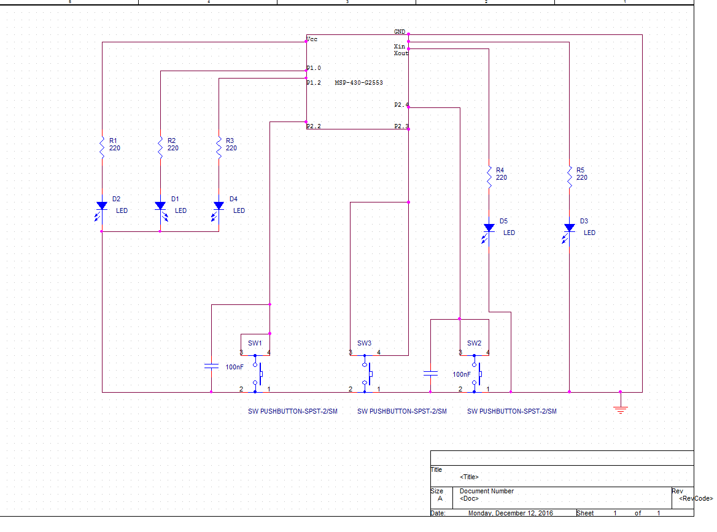 (Firestone, 2016)

##### **Results:**

Our results were not exactly what we were looking for. The Air freshener simulation (as shown in video) doesn’t toggle the 3 different functions on its own but instead the 3 existing LEDs work directly with corresponding switches. We altered the original schematic to demonstrate what the air freshener simulation was supposed to do to the best of our ability and knowledge.

**Discussion:**

During our project, we had trouble implementing the code for the push buttons. We didn’t know exactly how to use interrupts/timers which was needed to successfully implement the code; therefore, we resorted to assembling a different board and attempting a different approach to accomplishing the goal. On the other hand, somethings were successful during our project. We managed to implement a 3-way air freshener that sprays in different speeds fast, medium and slow (SHORT, MEDIUM, LONG) therefore naturally one will leave the LONG function on longer than the SHORT function in order to dispense an equal amount of air freshener. We also managed to implement some kind unofficial low-power mode that basically pauses the system while active.

**Conclusion:**

In conclusion, although our results weren’t what we wanted we did learn a lot by doing this project, by trial and error we learned different approaches to trouble shooting codes and the board. We all and all really enjoyed the opportunity and looking forward to one day soon being able to put this project together properly.

**References**

Ünsalan, C., & Gürhan, H. D. (2014). Programmable microcontrollers with applications: